**Project Design Phase**

**Solution Architecture**

|  |  |
| --- | --- |
| Date | 23rd May 2025 |
| Team ID |  |
| Project Name | BookNest |
| Maximum Marks | 4 Marks |

**Solution Architecture:**

**Solution architecture is a strategic and multifaceted process that connects business challenges with effective technological solutions. It involves several interrelated activities with the following key objectives:**

* **Identifying the most suitable technology to address current business needs.**
* **Communicating the system's design, structure, functionality, and behavior to stakeholders in a clear and comprehensive manner.**
* **Defining core features, development stages, and technical and business requirements of the solution.**
* **Establishing detailed guidelines and specifications for how the solution will be planned, developed, implemented, and maintained.**

**Example - Solution Architecture Diagram:**

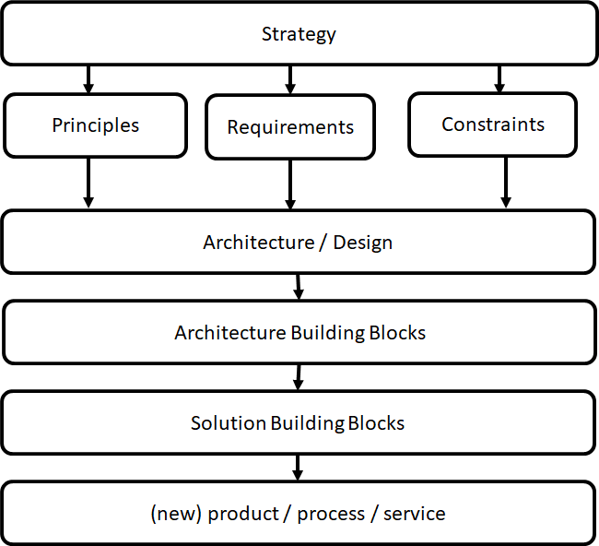

[This Photo](https://nocomplexity.com/documents/fossml/architecture.html) by Unknown Author is licensed under [CC BY-SA](https://creativecommons.org/licenses/by-sa/3.0/)

*Figure 1: Architecture and data flow of the voice patient diary sample application*

**Reference:** [**https://aws.amazon.com/blogs/industries/voice-applications-in-clinical-research-powered-by-ai-on-aws-part-1-architecture-and-design-considerations/**](https://aws.amazon.com/blogs/industries/voice-applications-in-clinical-research-powered-by-ai-on-aws-part-1-architecture-and-design-considerations/)